NAME: Ch. usha sri

ROLL NO:21481A0223

Data Analytics

Assignment 3

1. Create Calculation Fields:

● Create a calculation field named "Average Discount Rate" to calculate the average discount rate across all orders.

● Create a calculation field named "Total Profit Margin" to calculate the total profit margin for each order.

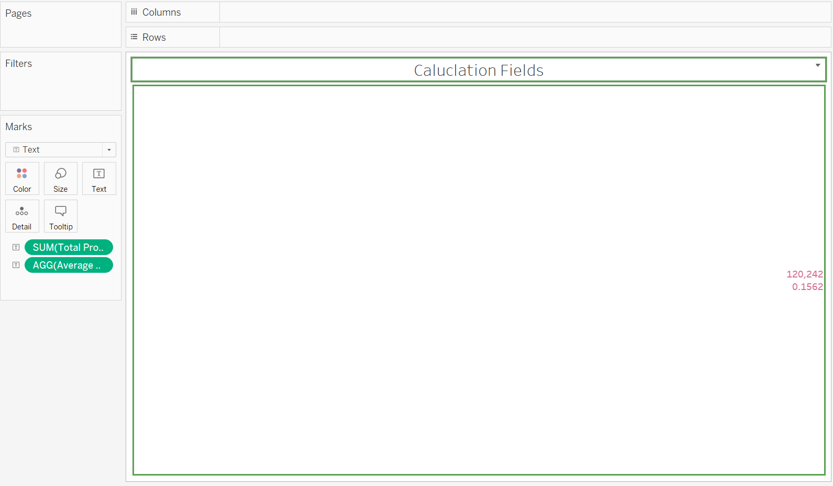

2. Data Blending :

● Blend data from the Superstore dataset with another dataset containing regional sales information.

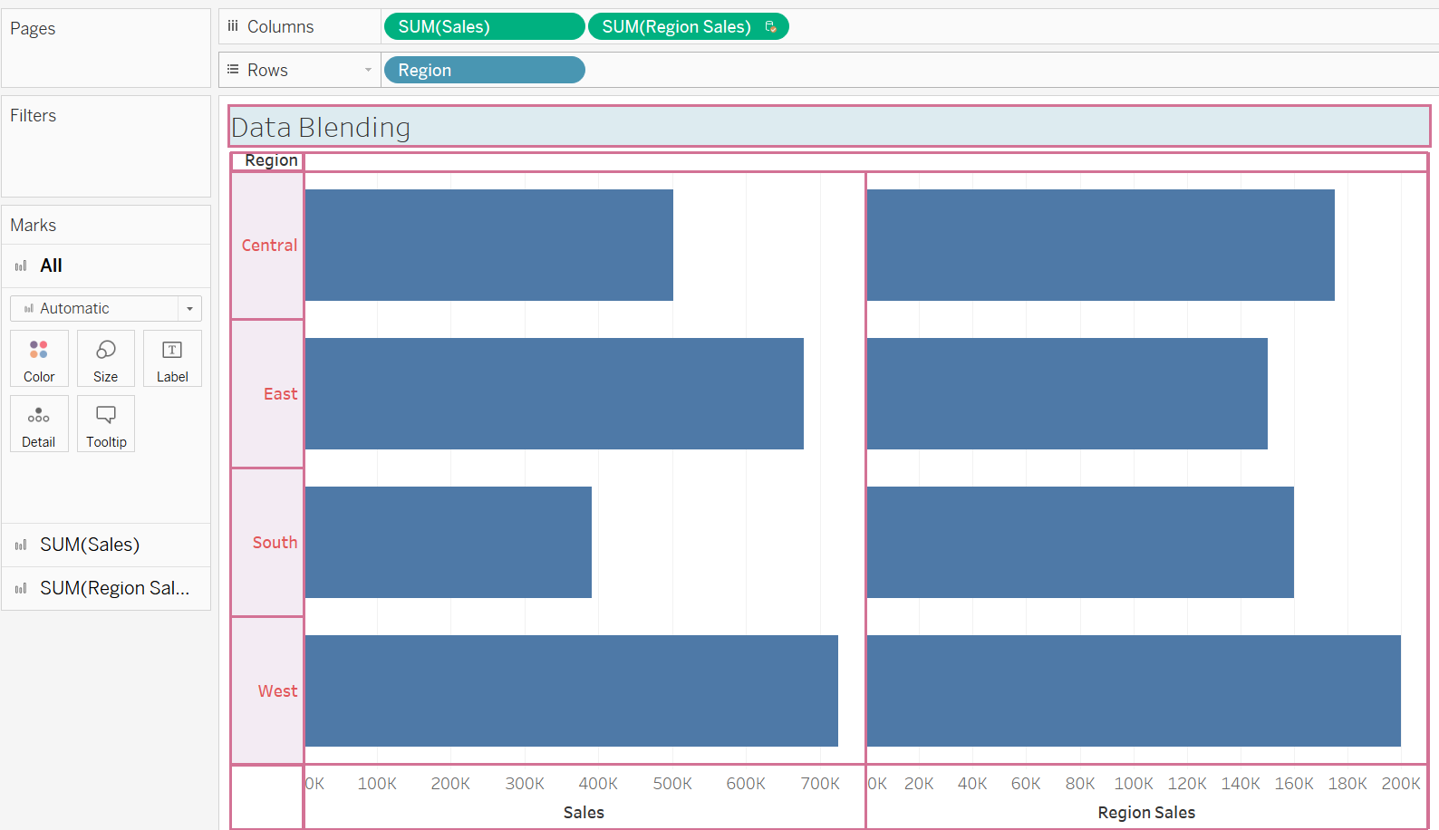

3. Actions

● Implement a highlight action to emphasize specific data points, such as highlighting the sales of top-performing products when a particular customer is selected.

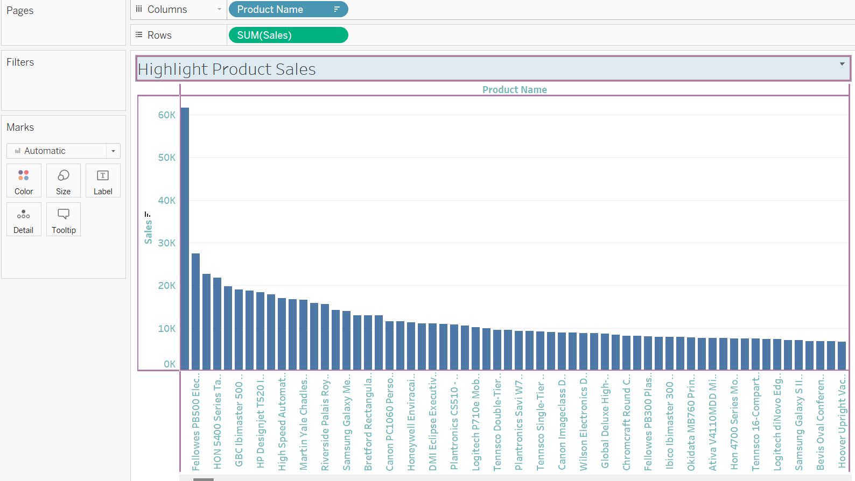

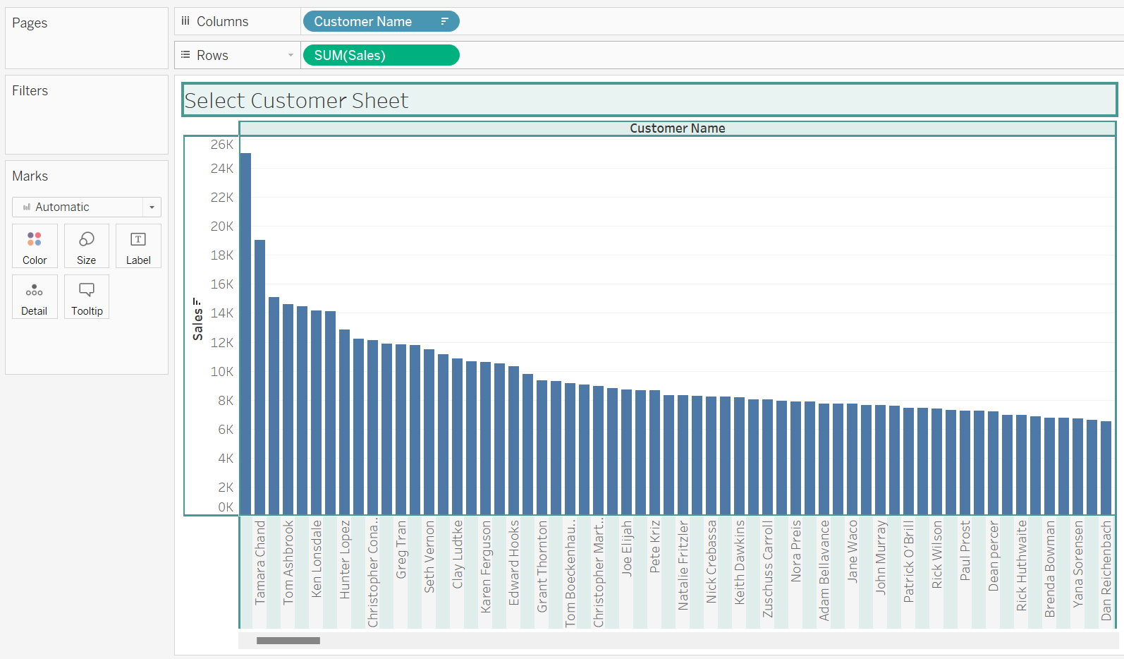

4. Sets

● Define at least two sets based on specific criteria from your dataset (e.g., high-value customers, top-performing products).

● Experiment with combining sets using UNION, INTERSECT, and MINUS operations.

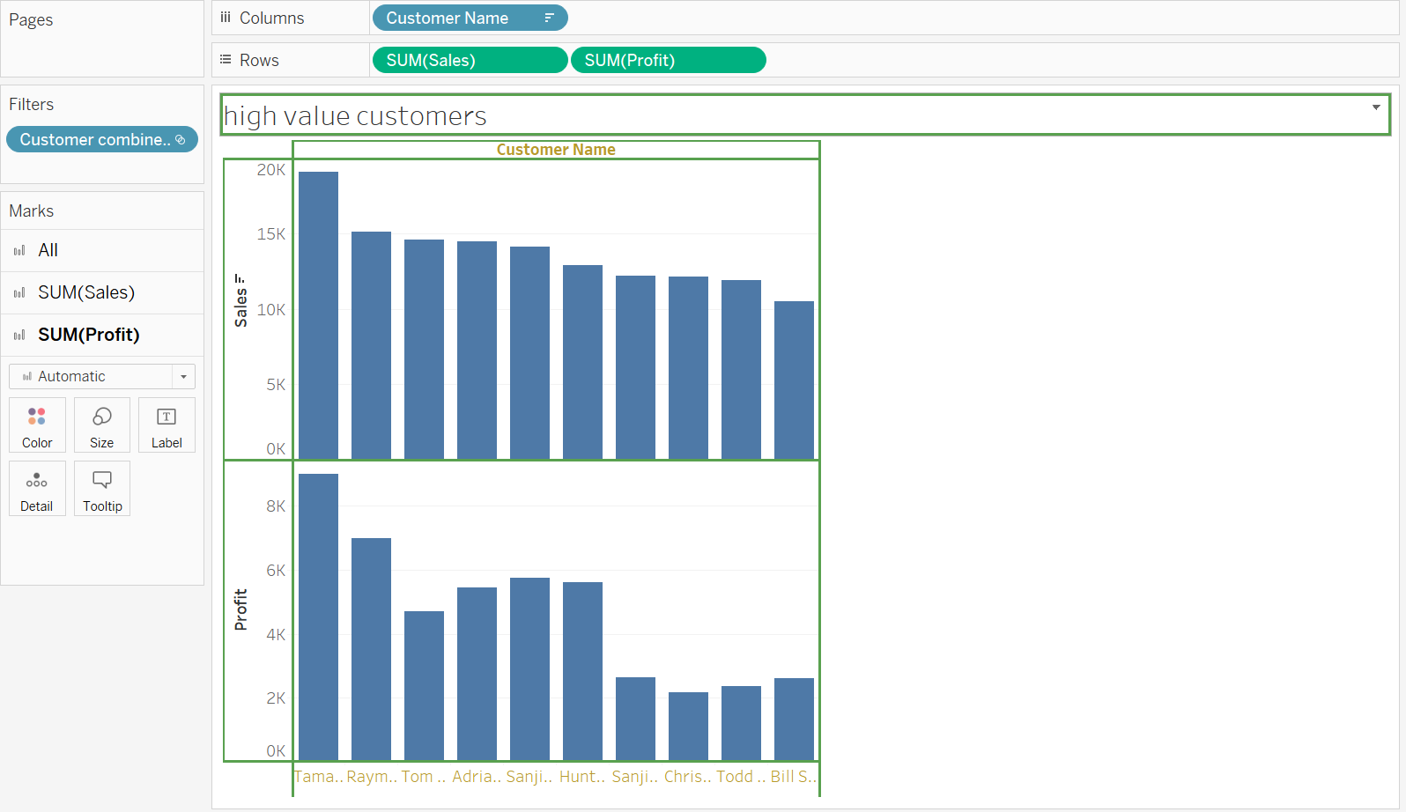

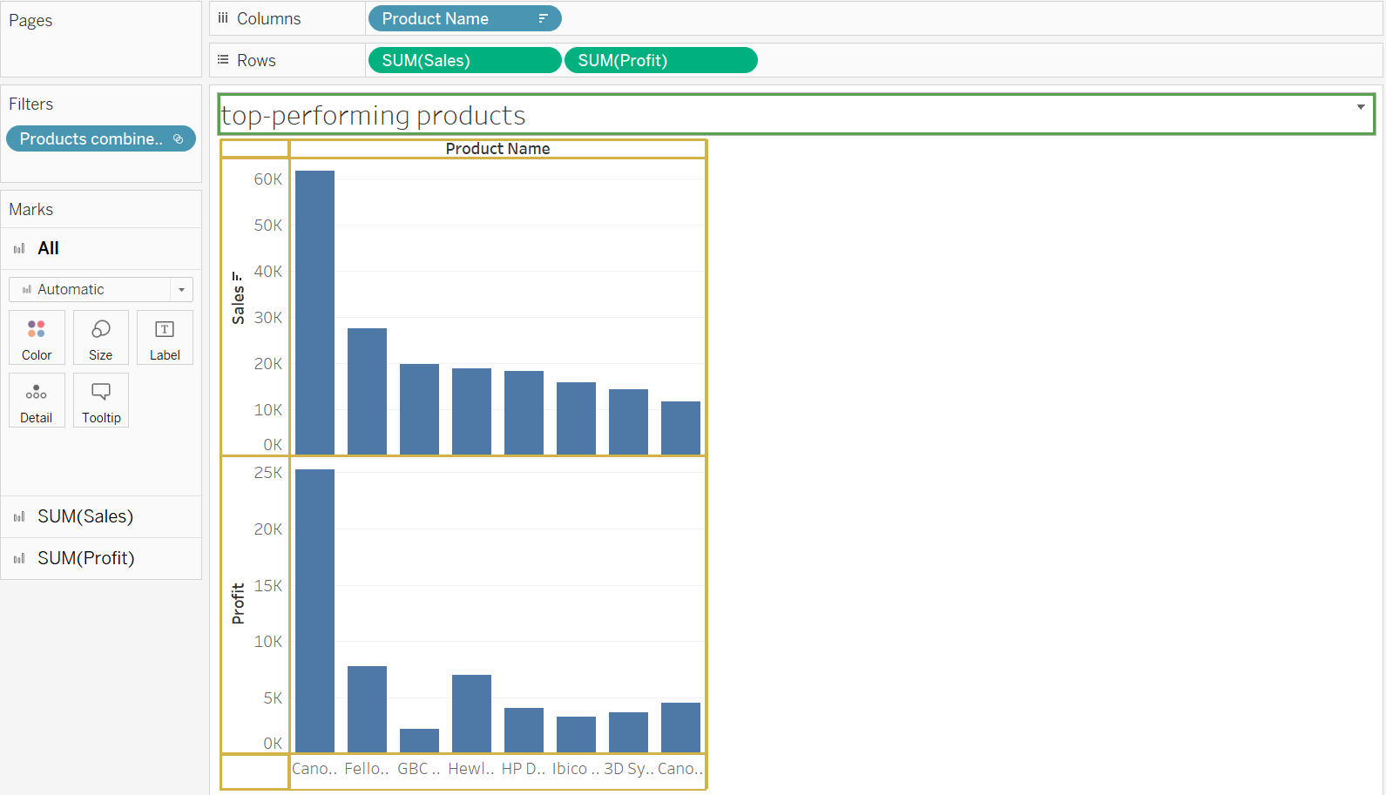

5. Parameters ● Implement a visualization and use parameters for the region column to allow users to select a specific region

